28 January 2026

Dear Parent or Carer,

RE: CERN visit to Geneva, Easter 2027

Following a large response to the CERN trip, I am sorry to let you know that unfortunately, your child was not successful in reserving a place on the CERN trip. All students who have been unsuccessful have been placed on the reserve list.

Should a student withdraw from the trip, we may offer your child a place. Should your child subsequently be allocated a place, an amended payment schedule will be communicated at the same time in order to bring payments into line with the payment schedule previously communicated.

Should you wish to discuss further details in person, please do not hesitate to contact me by email at hobie.greenfield@driffieldschool.org.uk.

Yours faithfully,

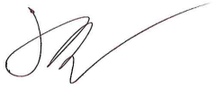

Mr H Greenfield
Visit Leader

