16 May 2025

Dear Parent or Carer,

**RE: Year 8 Personal Development Event**

On Thursday 12 June (5 - 6.30 pm), we would like to welcome you to Driffield School to hear about the ongoing work to support your child’s personal development. At the beginning of this year, we outlined the hybrid model of progress evenings and we are aware that Year 8 parents and carers have not had the opportunity to visit the school in person. In addition to a presentation in East Hall, you will have opportunity to visit a number of different stalls on each aspect of personal development, speak with staff leads and student leaders. Refreshments will also be available.

**Stalls will include:**

* APEX curriculum
* Attendance
* Careers
* EBacc pathway in Year 9
* Student Leadership opportunities
* Extra-curricular opportunities
* Driffield Sixth Form
* MIND

If you would like to attend this evening, please complete this short form here by Friday 23 May 2025: <https://forms.office.com/e/6dbp8uDJs8>.

Yours faithfully,

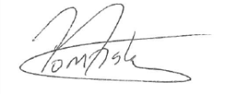

Mr T Fisher

Assistant Headteacher